VS Code & VueJS app running in localhost: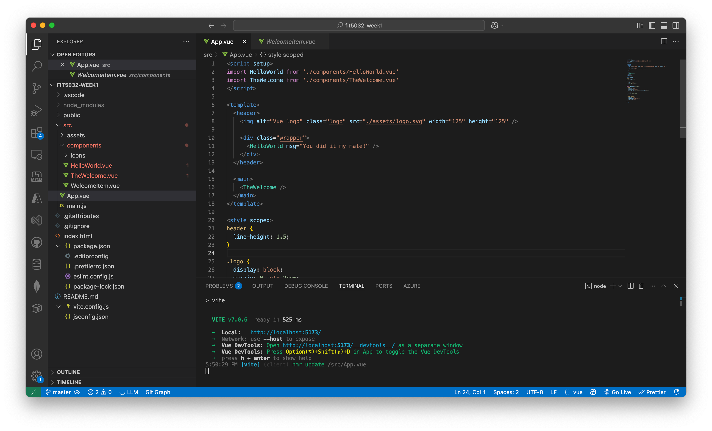

VS Code with AlanTseng.vue file open:

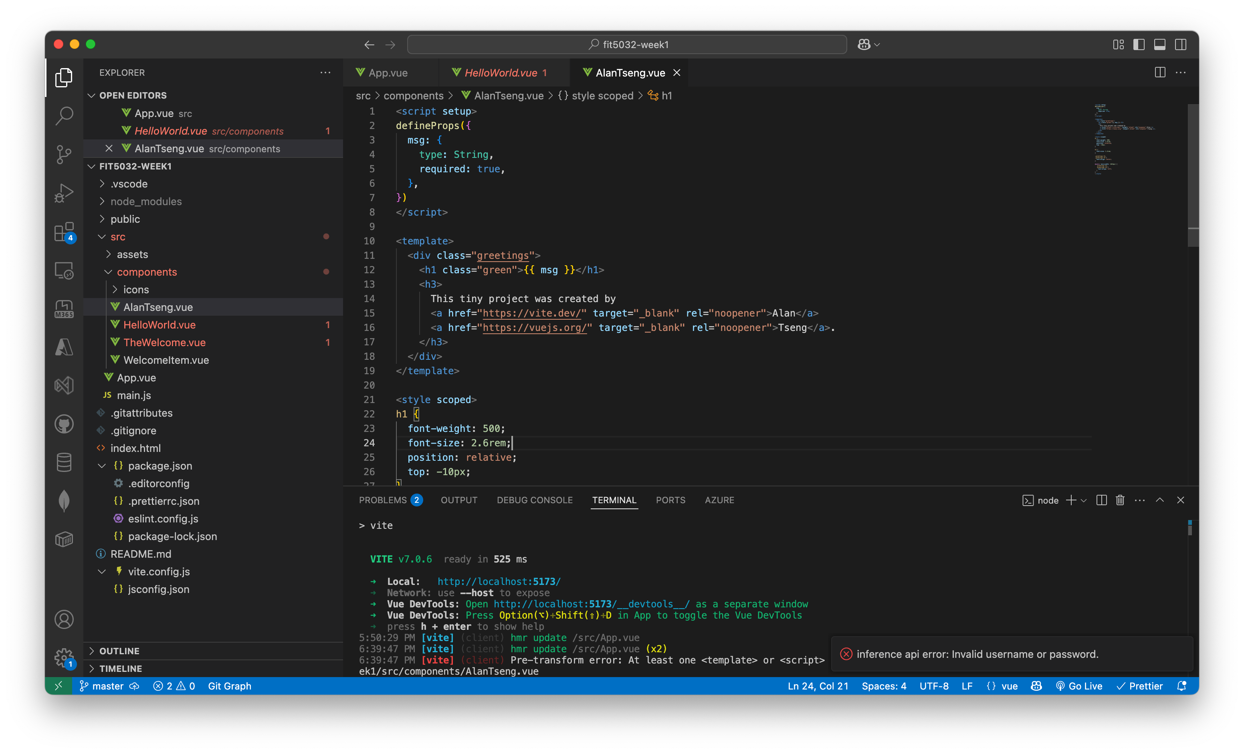

Browser window with the modified welcome page:

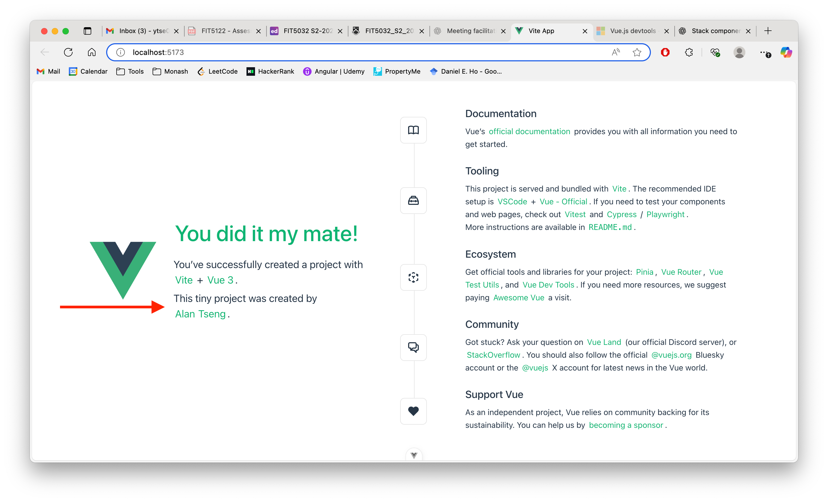

Github URL:

https://github.com/AlanTseng0012/FIT5032